

Falkirk Council Children’s Services

Establishment Improvement Planning Cycle

Unique Context
Stage 2

National Expectations
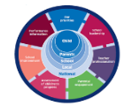
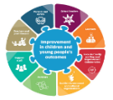
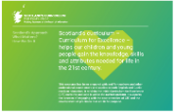






Community – Demographic, geographical and economic influences  The school roll has grown for a 4th consecutive year. The school currently caters for 410 pupils. It is set to increase again next year.  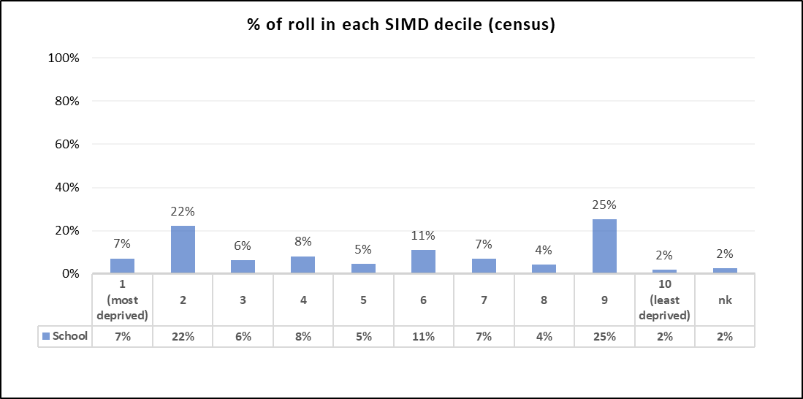  - 29% of our learners are living in SIMD deciles 1 and 2, with another 27% of our pupils in SIMD 9 and 10.  - The school is almost evenly split between deciles 1-5 (48%), and deciles 6-10 (49%)  - 20% of the school’s pupils (13% above the authority average) are registered as having English as an Additional Language (EAL)  - The school has well-established, strong, links to our local parish, St Francis Xavier’s RC Church. We are ably supported by our School Chaplain Fr Matthew Ngiye.  - We make use of our well-developed playground woodland area, and Dollar Park to facilitate outdoor learning opportunities.  - We have highly effective professional partnerships with many different agencies; Health, Social Work, Police Scotland, Educational Psychology, Speech and Language Therapy, Aberlour and Falkirk’s Employee and Training Unit regularly contribute to planning for our children and families.  - The Falkirk cluster, in which St Francis Xavier’s Primary School is geographically located, is above the Falkirk average (Census 2020) for those with no qualification, bad or very bad general health, and for those with a long term limiting health problem.  - 25.4% of people are income deprived.  - 20.6% of people are employment deprived.  - 27.3% of people are prescribed drugs for anxiety, depression or psychosis.  - Average school attendance is 70%  - Bainsford, Langlees and Camelon East are in the top 5% areas of highest deprivation  - The SIMD ranking of our immediate school area has increased from 1187 in 2016 to 761 in 2020  34% of children in the school are registered as having an additional support need. This is 7% higher than the authority average. | Attendance and Exclusion  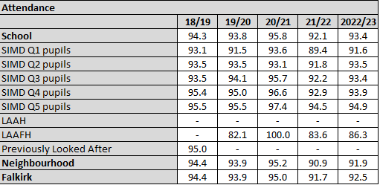  Attendance has improved across all quintiles from session 21/22 – 22/23. Quintile 1 has the lowest average attendance, with a difference of 2.3% between Q1 and Q5.  The overall school attendance has improved to 93.4% from the previous year's low of 92.1%.  Attendance for SIMD Q1 pupils increased from 89.4% in 2021/22 to 91.6% in 2022/23. This recovery is a positive sign of improved engagement among the most deprived students.  Attendance for SIMD Q2 pupils remained steady at 93.5% from 2021/22 to 2022/23, showing consistency.  Attendance for SIMD Q5 pupils increased slightly from 94.5% in 2021/22 to 94.9% in 2022/23, showing continued high engagement and a slight improvement.  Attendance for LAAFH students increased from 83.6% in 2021/22 to 86.3% in 2022/23. This is a positive trend indicating better engagement and support for these students.  Significant improvement in attendance among SIMD Q1 pupils suggests that efforts to support the most deprived students are having a positive impact.  Stability and slight improvements in attendance for SIMD Q2, Q3, Q4, and Q5 pupils show consistent engagement across different socioeconomic groups.  The increase in attendance for LAAFH students highlights positive outcomes from targeted support for vulnerable groups.  Following participation in the RIC attendance pilot, we now have systems and procedures in place. Attendance sits on the remit of a member of the senior leadership team. We are working with families (particularly those in Q1) to remove barriers which impact on school attendance.  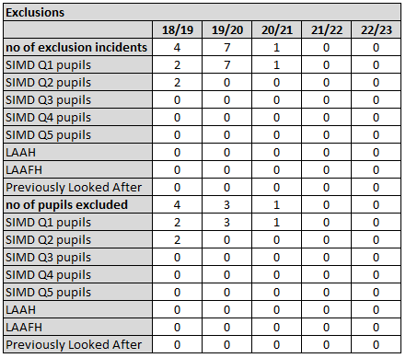  Exclusions remain at 0. Use of the CIRCLE framework, implementing our positive behaviour policy, Emotion Works, the school’s TP, classroom nurture spaces, Boxall, and carefully planned interventions have all supported here. The school’s TP offers an effective alternative to exclusion. | Progress and Attainment  Notable improvements across all areas for Q1 pupils, particularly in Reading (63% to 81%), Listening & Talking (76% to 87%), and Numeracy (66% to 83%). This indicates our PEF initiatives are having a positive impact.  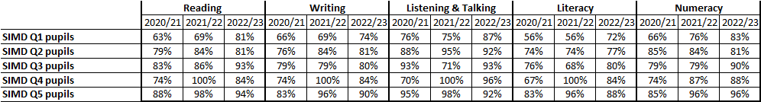  Reading:  - P1: Consistent high achievement with 87% in 2021/22 and 2022/23.  - P4: Improved from 78% in 2020/21 to 87% in both 2021/22 and 2022/23.  - P7: Significant improvement from 74% in 2020/21 to 88% in 2022/23.  - Combined P1/4/7: Increased from 77% in 2020/21 to 87% in 2022/23.  Writing:  - P4: Improved from 73% in 2020/21 to 84% in 2022/23.  - P7: Maintained 81% from 2021/22 to 2022/23, up from 71% in 2020/21.  - Combined P1/4/7: Improved from 76% in 2020/21 to 82% in 2022/23.  Listening & Talking:  - P1: High achievement, with an increase from 83% in 2020/21 to 93% in 2021/22, slightly decreasing to 90% in 2022/23.  - P7: Improvement from 78% in 2020/21 to 91% in 2022/23.  - Combined P1/4/7: Increased from 85% in 2020/21 to 92% in 2022/23.  Literacy:  - P1: Increased from 77% in 2020/21 to 87% in 2021/22.  - P4: Significant improvement from 68% in 2020/21 to 84% in 2022/23.  - P7: Improved from 69% in 2020/21 to 81% in 2022/23.  - Combined P1/4/7: Increased from 71% in 2020/21 to 81% in 2022/23.  Numeracy:  - P1: Increased from 85% in 2020/21 to 91% in 2021/22, slightly decreasing to 89% in 2022/23.  - P4: Significant improvement from 80% in 2020/21 to 92% in 2022/23.  - P7: Improved from 71% in 2020/21 to 84% in 2022/23.  - Combined P1/4/7: Increased from 78% in 2020/21 to 88% in 2022/23.  Gap Analysis (Q1 vs. Q5):  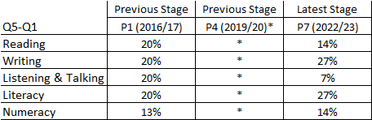  The gaps between SIMD Q1 and higher quintiles (e.g., Q5) are showing signs of closing, particularly in areas like numeracy and Listening & Talking, where SIMD Q1 pupils have shown strong, positive improvements.  Reading:  - P1: Gap reduced significantly from 21% in 2020/21 to 10% in 2022/23.  - P7: Gap reduced significantly from 25% in 2020/21 to 14% in 2022/23.  - Combined P1/4/7: Gap reduced from 24% in 2020/21 to 13% in 2022/23.  Writing:  - P1: Gap reduced from 14% in 2020/21 to 2% in 2022/23.  - Combined P1/4/7: Gap reduced from 17% in 2020/21 to 16% in 2022/23.  Listening & Talking:  - P1: Significant improvement with the gap reduced from 36% in 2020/21 to -10% in 2022/23, indicating Q1 pupils outperformed Q5 pupils.  - P7: Gap reduced from 21% in 2020/21 to 7% in 2022/23.  - Combined P1/4/7: Gap reduced from 20% in 2020/21 to 5% in 2022/23.  Numeracy:  - P4: Gap reduced from 40% in 2020/21 to 23% in 2022/23.  - P7: Gap reduced from 25% in 2020/21 to 14% in 2022/23.  - Combined P1/4/7: Gap reduced from 20% in 2020/21 to 13% in 2022/23.

Priority Area:  Raising attainment through effective use of data | 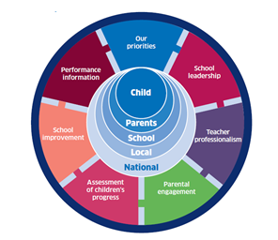  School and ELC leadership  Stage 3  Teacher and practitioner professionalism  Parental/Carer involvement and engagement  Curriculum and assessment  School and ELC improvement  Performance information |   Leadership and Management  QI: 1.1, 1.2, 1.3, 1.4, 1.5  Learning Provision  QI: 2.1, 2.2, 2.3, 2.4, 2.5, 2.6, 2.7  Successes and Achievements    QI: 3.1, 3.2, 3.3 |   Curriculum  Learning and Teaching  Inclusion and Equality  Assessment
What informs this priority?

Next steps from last year’s school improvement plan
Introduction of Progress
How good is our school? (4th edition) (education.gov.scot)
Data Impact Toolkit (education.gov.scot)
Effective use of data literature review | Effective use of data | Resources | Education Scotland
Effective use of data | Resources | Education Scotland
Pupil attainment: closing the gap - Schools - gov.scot (www.gov.scot)
How good is our school? (4th edition) (education.gov.scot)
The Standard for Full Registration (gtcs.org.uk)

What do you aim to achieve?  Raising attainment through effective use of data  Falkirk Council Stretch Aims being achieved  Gather a range of data and information to monitor and track progress for all learners  Regularly interrogate data  Make effective use of current available data on levels of child poverty and apply this to ensure equity  All practitioners have well-developed skills of data analysis  The school’s data demonstrates our current learners are making very good progress | How will you achieve this priority?  Effective data collection and management; effective data analysis and interpretation: data-driven instruction and intervention:  Identify Data Sources: Look beyond standardized tests. Consider formative assessments, classroom observations, student surveys, attendance records, and parent feedback. Staff developing a shared understanding.  Training on new system: Implement new system (Progress) for collecting, storing, and analysing data efficiently. Ensure it is accessible to all relevant staff.  Data Quality and Consistency: Ensure data is accurate, complete, and collected consistently across the school. Create assessment rationale. What does assessment look like in St Francis Xavier’s?  Professional Reading, training and support: Make use of Education Scotland Literature Review, Data Collection Toolkit, and Effective Use of Data resources.  Regular Data Analysis Cycles: Establish regular cycles (e.g., weekly, termly) to analyse data and track student progress. Schedule meetings where teachers collaborate and discuss student data. This will include Staff development days, CAT sessions, Level meetings and planning and tracking meetings. This will also be a focus of senior leadership meetings.  Focus on Progress, not just Attainment: Analyse data to understand individual student progress, not just overall attainment. This helps identify students needing extra support or those exceeding expectations.  Excellence and Equity Data Toolkit: Utilize this toolkit to gather and analyse relevant data, ensuring that the data is used effectively to inform teaching practices and interventions  Targeted Interventions: Based on data analysis, develop targeted interventions for struggling students. This could involve differentiated instruction, small group sessions, or individual learning plans.  Track the Impact of Interventions: Monitor the effectiveness of interventions through ongoing data collection and adjust strategies as needed. Celebrate successes and share best practices.  Feedback from Stakeholders: Gather input from teachers, students, and parents to provide a comprehensive understanding of factors affecting attainment. (Parent Council, Pupil Council, Learning Walks, Observations, CAT Sessions, Self-evaluation) | Timescales and responsibilities  Ensure school leadership team promotes and models data-driven decision-making.  SLT and teaching staff through collegiate working and professional learning (Aug 24)  SLT and teaching staff trained by Kimberly Robinson (Aug 24). Professional dialogue between colleagues, and SLT and teaching staff focussed on effective use of Progress (Ongoing)  Ongoing through planning and tracking meetings  Assessment rationale created through collegiate sessions by teaching staff and SLT by May 25  Access training on data analysis tools and techniques. Work to interpret data to identify trends, strengths, and areas for improvement. All staff Aug 23 – Jun 25  SLT and teaching staff will continue to analyse data as part of ongoing quality assurance procedures. Further opportunities will be built in to collegiate sessions for application of training (Aug24 – Jun 25)  }  Staff will use data to inform the creation of Specific, Measurable, Achievable, Relevant, and Time-bound learning goals for individuals, groups, and the class as a whole. This will be recorded as part of the 20% Support/Challenge Proforma.  Carry our audit of existing data collection and application of data.  }  }  SLT to organise focus groups, add agenda items to Parent and Pupil Council, and factor in to ongoing quality assurance procedures. Select relevant section of HGIOURS to support pupil council work. | Measures of success  (What on-going information will demonstrate progress? (Qualitative, Quantitative - short / medium / long term data)  Teacher Surveys: Conduct surveys to gauge teacher comfort levels with data analysis and its use in informing instruction. (pre and post)  HGIOS?4 Framework: Use the self-evaluation and quality indicators from the HGIOS4 framework to regularly assess and refine practices.  Focus Group Discussions: Organize focus groups with teachers to discuss the effectiveness of data-driven interventions and strategies. (As part of level meetings)  Assessment results: Monitor improvements in students' attainment on formative and summative assessments. Cohorts of students tracked over several years to measure sustained improvement in academic performance. Make use of SNSA, ACEL and School Contextual Profile (Issued October 24)  Attendance Rates: Track changes in attendance rates, as regular attendance is often correlated with improved academic performance. Supported by monthly attendance reports.  Participation Rates: Measure student participation in targeted interventions and support programs.  Gaps: Analyse data to see if the gap between the highest and lowest performing students is narrowing. (based on factors like socioeconomic background or disability)  Behavioural Data: Track incidents of behavioural issues and note any reductions that may correlate with improved engagement and attainment. (Time In; CIRCLE Framework).  Parental Feedback: Surveys, Parent Council meetings, Snapshot Weeks and Parents’ Evenings used to understand parents' perspectives on their children's progress and the effectiveness of communication regarding data-driven interventions.  Student Portfolios: Review student work portfolios for evidence of improvement and increased complexity in assignments. (Snapshots Weeks)  Learning Walks and Observations: Regular learning walks and classroom observations to see the implementation of data-driven strategies and their impact on teaching practices. This will be linked to school’s quality assurance calendar.  Post-School Outcomes: For older primary students, track transition rates to secondary education and their success in the first year of secondary school. Link with St Mungo’s to support.  Case Studies: Develop case studies of individual students or groups who have shown significant progress to understand the factors contributing to their success. This will be carried out as a test of change this session.  Increased Use of Data in Lesson Planning: Track the number of planning agendas and evaluations that explicitly reference student data to inform instruction.  Completion of Targeted Interventions: Monitor the completion rate of targeted interventions designed based on student data analysis. 20% support/Challenge Proforma to support  Teacher Observations: Conduct focused observations to see how teachers are using data to guide classroom instruction and provide feedback.  Staff Meetings Focus: Frequency and focus of staff meetings dedicated to data analysis and collaboration.
Ongoing evaluation/actual impact:

Priority Area:  Curriculum Rationale | School and ELC leadership  Teacher and practitioner professionalism  Parental/Carer involvement and engagement  Curriculum and assessment  School and ELC improvement  Performance information | Leadership and Management  QI: 1.1, 1.2, 1.3, 1.4, 1.5  Learning Provision  QI: 2.1, 2.2, 2.3, 2.4, 2.5, 2.6, 2.7  Successes and Achievements  QI: 3.1, 3.2, 3.3 | Curriculum  Learning and Teaching  Inclusion and Equality  Assessment
What informs this priority?

Primary Curriculum Improvement Toolkit | Resources | National Improvement Hub (education.gov.scot)
Learning To Achieve – A Falkirk Council Children’s Services Policy (glowscotland.org.uk)
Scotland's Curriculum for Excellence (scotlandscurriculum.scot)
Resources to Support Scotland’s Curriculum Framework | Resources | Education Scotland
The Standard for Full Registration (gtcs.org.uk)

What do you aim to achieve?  We work together as a school community to develop, promote and sustain an aspirational vision for our curriculum.  All stakeholders are able to talk about how the unique features of the school community inform the design of the curriculum  The curriculum has a clear vision and rationale shaped by the shared values of the school and its community.  There is a strategic overview which we use to ensure a shared understanding of the purpose and design of the curriculum.  We use learning and teaching approaches and the curriculum to promote resilience, and responsible citizenship.  The curriculum effectively promotes safeguarding and wellbeing across all stages, taking good account of the context of the school.  Our curriculum is grounded in our commitment to securing children’s rights and wellbeing. It takes account of learners’ entitlements and the four capacities and reflects the uniqueness of our setting.  The structure of the curriculum provides equity of opportunity to maximise the successes and achievements of all our learners.  We take very good account of the four contexts for learning and cross-cutting themes such as equality, enterprise, creativity, sustainable development education and international engagement.  Our creative and innovative approaches to curriculum design support positive outcomes for learners.  Our curriculum is regularly reviewed and refreshed by an informed awareness of current education thinking and evolves through ongoing debate within the school community.  We work well with partners to ensure creative and innovative approaches to curriculum development are encouraged and support positive outcomes for learners.  The development of our curriculum is underpinned by a coherent whole school approach to learning for sustainability.  Our curriculum has a strong focus on developing the skills our young people need in the world of work.  Outdoor learning is a regular, progressive curriculum led experience for all learners.  Opportunities to develop creativity skills are evident across all areas of the curriculum | How will you achieve this priority?  Form a curriculum development committee that includes teachers from various levels/stages, school leaders, parents, partners and community members.  Gather data on current curriculum strengths and weaknesses through surveys, focus groups, and assessment results.  Identify gaps and areas for improvement by reviewing student performance data and feedback from teachers and parents.  Analyse the current curriculum rationale and compare it with national standards, guidelines, and best practices in education.  Engage stakeholders in defining the core values and educational goals that the curriculum should reflect. Ensure these goals align with the school's vision, values and aims.  Develop a preliminary rationale statement that outlines the purpose, goals, and underlying principles of the curriculum.  Include how the curriculum will meet the diverse needs of students and prepare them for future academic and personal success.  Share the draft rationale with all stakeholders, including teachers, parents, students, and community members.  Collect feedback through surveys, meetings, and focus groups to refine and improve the rationale. Focus groups should prioritise:  - School Values: What core values should the curriculum promote? (e.g., creativity, critical thinking, collaboration)  - Learner Profile: Who are we aiming to educate? What are their strengths and needs?  - Curriculum Aims: What do we want students to achieve by the end of primary school? (e.g., knowledge, skills, dispositions)  - Cross-curricular Links: How can subjects be integrated for a more holistic learning experience?  Provide professional development opportunities for teachers on the new curriculum rationale and how to implement it effectively in the classroom.  Offer ongoing support and resources to help teachers align their instructional practices with the new rationale. This will take place through our ongoing quality assurance procedures, and ERD process.  Clearly communicate the final curriculum rationale to the entire school community through meetings, newsletters, and the school website.  Establish a system for monitoring the implementation of the curriculum rationale and evaluating its impact on teaching and learning.  Use data and feedback to make ongoing adjustments and improvements to the curriculum rationale as needed.  Celebrate the collaborative effort and the successful development of the shared curriculum rationale with the school community.  Reflect on the process to identify lessons learned and areas for future improvement in curriculum development. | Timescales and responsibilities  SLT to coordinate as part of school leadership roles. To be established for Sep 24, and meet regularly, as required, throughout the session.  Microsoft form sent to all parents to gather views. Shared with, and analysed by, Parent Council.  Part of ongoing Effective Use of Data improvement priority.  Teaching staff as part of collegiate working. September/October 24  Information gathering throughout Parents’ Evenings. October 2024  SLT, along with curriculum development committee. December 2024  SLT and specific staff members at Parents’ Evening. February 2025  SLT and specific staff members at Parents’ Evening. February 2025  Senior leadership team. Times set out in quality assurance calendar.  Headteacher and curriculum development committee. Apr/May 25  Senior leadership team. May 25 (to be used in session 25/26)  All staff  Whole school community. Apr/May 25  } | Measures of success  (What on-going information will demonstrate progress? (Qualitative, Quantitative - short / medium / long term data)  Meeting participation: Track attendance and active participation in workshops and discussions by teachers, leaders, and stakeholders involved.  Analyse feedback from the questionnaires and discussions to identify key themes.  Track the number of stakeholders who contribute their voice to the process.  Evaluate the draft document for its clarity, conciseness, and alignment with gathered information.  Teacher and parent feedback on draft rationale: See if the draft resonates with stakeholders and addresses their concerns.  Level of agreement within the school community: Assess the overall acceptance of the draft rationale by the staff and parents.  Track the number of revisions and adjustments made to the draft based on stakeholder feedback.  Curriculum coherence across subjects and year groups: Observe lesson plans and classroom practices for alignment with the shared curriculum rationale.  Student understanding of school values and learning goals: Talk to students about their perception of the school's values and expected learning outcomes.  Student performance data: Over time, track student performance in standardized tests or internal assessments to see if the curriculum is leading to improved learning outcomes. (This can be a lagging indicator and should be considered alongside qualitative measures)  Number of stakeholders (teachers, parents, students) participating in meetings, workshops, and feedback sessions.  Percentage of teachers who are actively incorporating the new curriculum rationale into their lesson plans (evidenced through weekly plans, termly planning, evaluations, ERD)  Teacher feedback through meetings (ERD/Planning and Tracking) and surveys on the usability and impact of the new curriculum rationale in their teaching.  Case studies and narratives highlighting improvements in meeting diverse student needs and promoting inclusivity. (Moderation/test of change)  Focus group discussions and open forums to gather in-depth feedback on the curriculum's impact.  Reflections from the curriculum committee on the sustainability of practices and continuous improvement processes. Identifying next etps for Standards and Quality Report.  CLPL Records and ERD: Tracking participation and feedback.
Ongoing evaluation/actual impact:

Priority Area:  Reigniting our Cluster Vision | School and ELC leadership  Teacher and practitioner professionalism  Parental/Carer involvement and engagement  Curriculum and assessment  School and ELC improvement  Performance information | Leadership and Management  QI: 1.1, 1.2, 1.3, 1.4, 1.5  Learning Provision  QI: 2.1, 2.2, 2.3, 2.4, 2.5, 2.6, 2.7  Successes and Achievements  QI: 3.1, 3.2, 3.3 | Curriculum  Learning and Teaching  Inclusion and Equality  Assessment
What informs this priority?

Reduction in number of shared cluster priorities over the past 3 years
Change in leadership (5 new cluster heads in the last 3 years)
Developing in Faith
How good is our school? (4th edition) (education.gov.scot)
RERC Principles and Practice
CfE Briefing 16 - Curriculum for Excellence: Religious Observance (Time for Reflection) (education.gov.scot)
Global Compact on Education | Global Compact on Education (educationglobalcompact.org)

What do you aim to achieve?  Reigniting our cluster mission through the development of a shared vision for our cluster, creating a shared sense of unity and purpose among all schools  All staff showing commitment to the shared vision  Active collaboration to ensure all school communities have ownership of the vision  Leaders at all levels motivating and inspiring others to sustain collective commitment to the shared vision through daily actions  Senior leaders providing strong leadership to enable our cluster community to develop, promote and sustain the aspirational vision, underpinning our continuous improvement.  Ensure that all students in the cluster receive a high-quality education that is rooted in Catholic values.  Develop learners holistically, focusing on spiritual, moral, social, and cultural development, to prepare them for life beyond school. | How will you achieve this priority?  Launch event with all cluster staff to set the scene, think about our why, our uniqueness and what is important to us as a cluster and faith community.  Establish a RACI group to develop cluster mission, consisting of staff, parents and pupils from across the cluster.  Gather input from parents, teachers, students, and other stakeholders. Conduct workshops and focus groups with representatives from all schools in the cluster to define shared goals.  Produce a short, memorable and inspiring mission statement, such as, Connected Through Christ, to be used across the cluster  Communicate the shared vision to all staff, students, and parents in the cluster.  Offer ongoing professional development for educators to enhance their teaching skills and understanding of the shared vision. This will include offerings from the archdiocese (e.g. God’s Loving Plan, Sacramental Workshops and Catholic School Leadership Programme) and school based CLPL on values based education.  Further develop cross-school collaboration and sharing of best practices.  Underline the importance of teaching values such as compassion, integrity, and justice. Embed these values into the curriculum, fostering a positive and supportive learning environment. A cluster approach to teaching experiences related to values will be taken (e.g. All Primary 6 pupils in the cluster focussing on a specific value, and sharing their learning with other pupils in school, and across the cluster. These core values will be Integrated into all aspects of the curriculum to ensure our cluster vision is realised.  Establish a system for monitoring and evaluating the implementation of the shared vision and its impact on student attainment and achievement.  Organise cluster events and projects that support the educational vision and foster a sense of belonging. For example Staff Development Days for cluster moderation, collective worship, etc.)  Implement support structures for students, including the shared 1.0FTE Inclusion Support Worker (attendance, inclusion, exclusion, etc.) allocated to the cluster.  Create platforms for sharing best practices and collaborative learning among educators. (cluster teams page) | Timescales and responsibilities  August Staff Development Day  Led by Barbara Couper, Director of SCES  All Cluster teaching staff attending  Representatives from each cluster school  Dates across the session to be agreed once group is established.  All cluster schools to gather data from relevant groups to be collected and analysed by RACI group. Dates will be agreed via RACI group when calendar is agreed.  Cluster RACI Group  By April 2025  All school leaders/priority leads  By May 2025  Ongoing throughout the session.  Archdiocese of St Andrew’s and Edinburgh (See CLPL Calendar)  School leaders delivering CLPL based on their school’s context (in line with WTA)  Ongoing throughout the session.  Focus of cluster working to be determined by school leaders August/September 2024. This will be built in to WTA and Staff Development Day planning  Values focus and timeline of delivery to be agreed at Cluster level. Sharing to take place with teachers and pupils using Microsoft Teams  }  Staff to complete surveys following cluster events (e.g. moderation). What % of teachers have seen the impact of cluster working on pupil attainment/achievement? What % of staff feel that these types of events show our shared vision being lived?  }  School leaders to collaborate on the effective distribution of this resource.  Support to be in place in schools August 2024  All staff sharing the outcome of cluster working via our St Mungo’s Cluster Improvement Hub | Measures of success  (What on-going information will demonstrate progress? (Qualitative, Quantitative - short / medium / long term data)  Teacher Collaboration: Measure the frequency and effectiveness of collaboration between teachers at different schools. This could involve surveys, observation of collaborative meetings, or tracking joint projects (such as the explicit teaching of values across the cluster)  Parental Engagement: Survey parents from each school to gauge their understanding and support of the shared vision. (Short Term)  Staff and Student Surveys: Conduct surveys of staff and students at regular intervals to assess their perception of the school environment, sense of community, and alignment with the shared vision.  Partnership Working: Monitor the frequency and effectiveness of shared professional development opportunities for staff across the cluster (staff surveys following cluster working). Look for changes in teaching practices and student outcomes linked to collaborative learning (through each school’s own quality assurance procedures).  School Culture: Observe and document changes in the overall culture of each school, aiming for a more cohesive and supportive environment across the cluster. This could involve looking for increased cooperation, a sense of shared goals, and stronger student-teacher relationships. (Medium/Long Term)  Community Engagement: Track and document the level of engagement with local communities across the cluster (e.g., number of parents from each cluster school attending transition events).  Celebrate successes and milestones achieved in moving towards the shared vision. Promote through newsletters, social media, and school events  Measure improvements in attendance and participation, and any reductions on exclusions, of pupils.
Ongoing evaluation/actual impact:

